Under the directive of
His Highness Sheikh Hamdan Bin Mohammed Bin Rashid Al Maktoum
Crown Prince of Dubai and Chairman of Dubai Executive Council
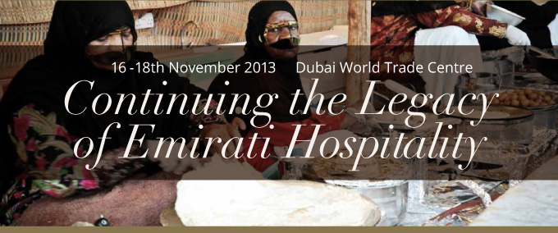
THE CHAMPIONSHIP |  | BREAKING IT DOWN |  | WHY THIS EVENT?
Under the directive of His Highness Sheikh Hamdan bin Mohammed bin Rashid Al Maktoum, Crown Prince of Dubai, Zaabeel Palace Hospitality is organizing DWHC 2013. DWHC, taking place at DWTC from 16 - 18 Nov 2013. The event is supported by ECG and WACS. |  | DWHC comprises three categories: the Emirati, the International and the Hospitality Sector Competitions. The venue will also host a Heritage village. The highlight of the event is the Emirati Competition, consisting of: Professional, Amateur, Emirati Homemade Dishes, and Emirati Homemade and Innovative Products categories. |  | DWHC is poised to benefit the hospitality sector in the UAE, giving hotels and restaurants an unprecedented boost. DWHC is set to grow as a coveted platform for experts in the hospitality sector. Prizes are anticipated to up the competition's ante and draw an enthusiastic turnout.
YOUR COMPLIMENTRY BADGE! |  | WIN A CAR!
Don't miss out on this opportunity to be a part of history in the making. Visit www.DWHC.ae to register for your complimentary badge. |  | The Lexus LX 570 embodies Luxury, comfort, style and entertainment features on an unprecedented scale. The LX 570 SUV is powered by a silky-smooth V8 engine that delivers exceptional performance on a prestige level. Grab your chance to win this luxury SUV courtesy of DWHC 2013!

For further information please contact: EMAIL INFO@DWHC.AE | TEL +971 56 6800449 / +971 4 336 9685
 | Opening Hours  Saturday 16th November 11.00 - 22.00  Sunday 18th November 11.00 - 22.00  Monday 19th November 11.00 - 22.00 |  | Follow Us On: facebook.com/DWHCDubai  twitter.com/DWHCDubai  instagram.com/DWHCDubai

Organised By | Supported By |  | Official  Hotel Partner | Official  Media Partner | Official Sponsors

