PRESS RELEASE
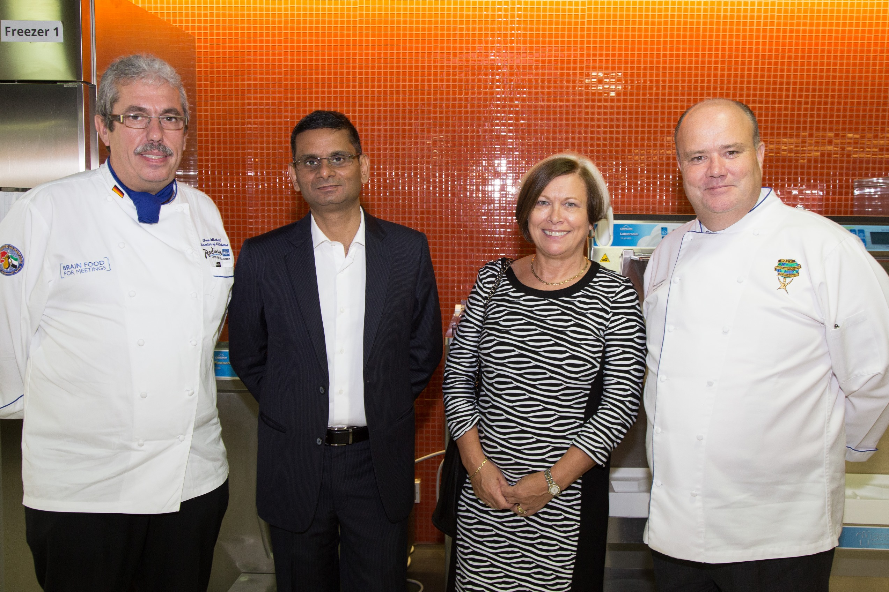
ICCA Dubai Launches AED 1Million Culinary ScholarshipAward
Dubai, UAE, 2 October 2014: The International Centre for Culinary Arts today launched the first of its kind 1 Million Dirham Continuing Education Award, an annual 100% Scholarship Programfor 30 young industry chefs.
This innovative, industry focused corporate social initiative will train &certify talented and deserving, but financially underprivlieged, young chefs in the UAE Hospitality industry.
The above scholarship initiative will be executedinstrategic partnershipwith the Emirates Culinary Guild, World Chefs (World Association of Chefs Societies) and City & Guilds London.
The programselection panel consists of Chef Andy Cuthbert, Chairman ECG and Young Chefs Development Team for WACS, Chef UweMicheel, President of ECG, Chef Alan Pedge, Vice President ECG Abu Dhabi and Mr Sunjeh Raja, Director and CEO, ICCA Dubai will select candidatesbased on a set criterion.
All candidates will be put through the intensive ICCA Dubai - International Chef Training Program, a City & Guilds London, accredited IVQ Level 2 Qualification, along with other Industry Skills Proficiency Training, through a 52 Week Day Release Program.During the 52 week programme, prominent chefs and industry experts will regularly conduct training sessions, imparting skills and knowledge aligned to the industry needs.
The Graduates of the Program will be eligible for WACS Certified Professional Cook, under the World Chefs Global Certification Scheme.

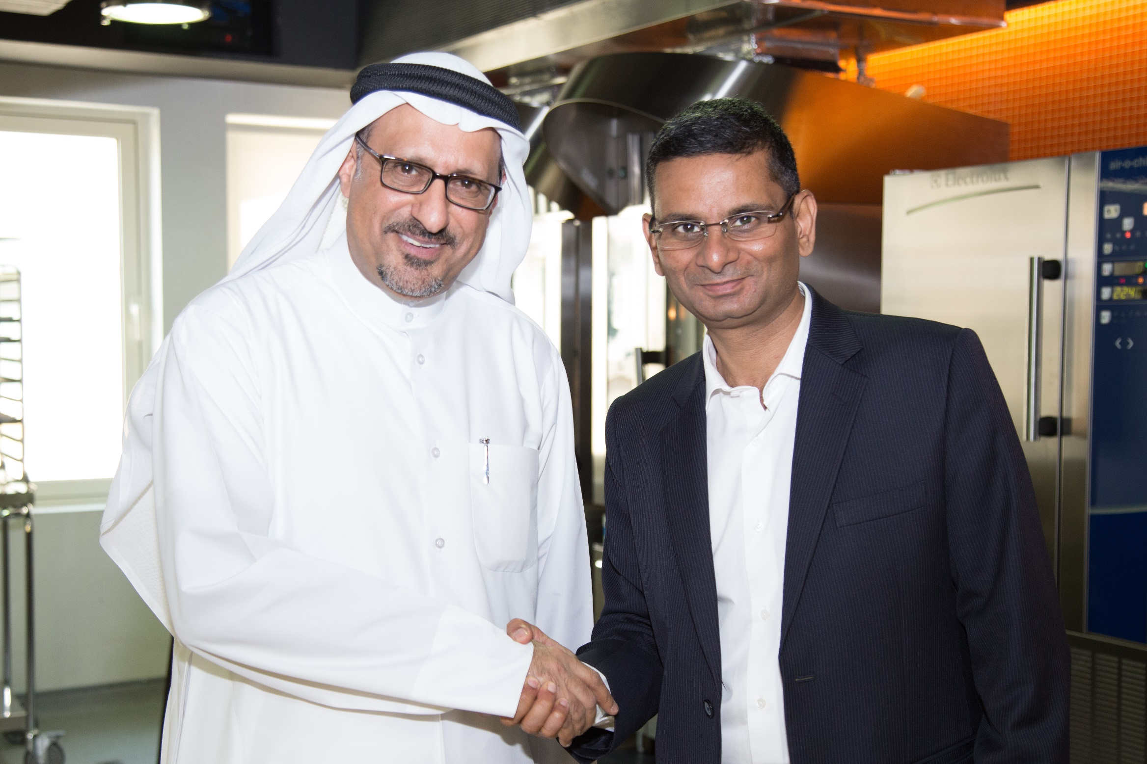
Sunjeh Raja, Director and CEO of ICCA presented the initiative saying, “The ICCA Dubai AED 1 Million Culinary Scholarship Award is the culmination of a vision we have had since we first opened our doors 10 years ago. It is a vision that couldonly be achieved with complete support from the industry and our strategic partners.This programme will completely change the lives of 30 underprivileged chefs a year, while simultaneously boosting the industry with fresh, skilled resources and thereby helping take things to the next level.”
He added that, “With Dubai Expo 2020 rapidly approaching,the UAE tourism and hospitality sector will experience massive growth, with an influx of139 new establishments, including 91 hotels and 48 hotel apartments to cater to the 25 million expected visitors. We need to show these visitors that our offering is world-class and this is where training is paramount to make the difference. Then there is also a strong need to build a legacy beyond Dubai Expo 2020 and to provide opportunities post-event to help sustain the industry. Training programs should be aligned to the opportunities and economic needs of the future – this is a smart approach to education, one that ties back to the Government’s wider vision of developing a knowledge-based economy. At ICCA Dubai, we are making that a reality.”
Chef Andy Cuthbert, as Chairman, ECG and as The Chairman Young Chefs Development Team for WACS explains, “The entire programme is designed to share knowledge, experience, expertise and capabilities to develop a sustainable workforce and strive for excellence through innovation, developing a socially inclusive working environment for the long-term.It is a tangible step in bridging skill gaps across the industry. We also recognise the importance in encouraging aspiring chefs to grow their skills to boost their careers within the hospitality industry, and this will give many a chance to fulfil their dreams without having to worry about the financial burden.”
Some of the guest lecturers include: Gary Rhodes (Celebrity Chef & Author), Christian Gradnitzer (Madinat Jumeirah), SachaTreimer (Atlantis the Palm), Terry Styles (The Conrad Dubai), Michael Kitts (Emirates Academy), Sebastian Nohse (JW Marriot Marquis), Osama El Sayed (Celebrity Chef), HaraldOberander (DWTC) Bobby Krishna (Dubai Municipality) Michael Wunsch (Barakat), Tarek Ibrahim (Master Chef, MLA – Australia), EmilianoBernsconi (Armani Hotel Dubai) and Roger Frei (Nestle) amongst others.
ICCA Dubai to date has trained over 2800 student chefs and maintains a record of 100% work placement for its students who have been successfully placed both in the UAE hospitality and international Cruise Line industry.
ICCA Dubai also offers industry certification & skills development programs in international best practices in food safety &hygiene that enables industry employees to stay on top of their continuous professional development, apart from a range amateur courses and personalized training programs. ICCA graduates are able do it all in the food world - they are successful chefs, restaurant owners, hospitality managers, entrepreneurs, food stylists, food writers and more.
ENDS

About ICCA:
Established in 2005, the International Centre for Culinary Arts (ICCA) Dubai is an industry centred vocational training (VET) centre. Specializing in culinary arts, ICCA's mission is to become the leading training provider in the Middle East with a vision to redefine ways in which professional and personal culinary training is offered. ICCA provides its students witha world class culinary experience at its state of the art, recently opened facility in Dubai Knowledge Village. It is a City & Guilds, London Approved Centre, delivering an International Vocational Qualification (IVQ) in Food Preparation and Culinary Arts. It is also recognised by The World Association of Chefs Societies, and locally works in partnership with the Knowledge & Human Development Authority (KHDA) and the Government and municipality of Dubai. ICCA is featured amongst the Top 10 Culinary Institutes in the World and has been awarded the “Recognition of Quality Culinary Education” by the World Association of Chefs Societies (WACS), a global authority on food standards. The “Recognition of Quality Culinary Education” award seeks to recognize training and education that meets or exceeds the culinary standards education established by WACS
About The Emirates Culinary Guild (ECG):
The Emirates Culinary Guild (ECG) is the UAE’s association of professional chefs. It is a non-profit-making organization dedicated solely to the advancement of the culinary industry of the UAE. The ECG received its charter into WACS at a ceremony in Stavanger, Norway on June 28, 1994, during the WACS 26th World Congress. WACS endorses the ECG as the authorised UAE culinary society. The ECG has an international culinary focus and multi-national support for the staging of its various competitions, seminars and events. The World Association of Chefs Societies (WACS) is a 100 nation fellowship comprising the world’s various professional chefs’ organisations.
About City & Guilds, London Accredited Training Programs & Qualifications:
Established in 1878 (136 Years old), City & Guilds is the World’s largest Vocation Awarding Body. It certifies over 1.3 Million students annually the worldover and helps increase value proposition and competitiveness within the Global Market. Accreditation is recognized as a sign of quality over a 100 countries around the world.
About The World Association of Chefs:
The World Association of Chefs' Societies, or Worldchefs, is a global network of chefs associations first founded in October 1928 (86 Years Old) and the venerable Auguste Escoffierwas the first Honourary President of Worldchefs.Today, this global body has 100 official chefs associations as members that represent over 10 million professional chefs worldwide.
For any press and interview enquiries please contact:
Megan Ballantyne
MBallantyne@bell-pottinger.com
M +971 5 555 97392

